**EXPLORING THE EFFECTIVENESS OF REMOTE LEARNING PLATFORMS**

**ABSTRACT:**

Exploring the Effectiveness of Remote Learning Platforms investigates the impact of various remote education tools on student engagement and learning outcomes. The study employs a comparative analysis of existing platforms, identifying challenges and opportunities. The proposed solution introduces novel features to enhance interactivity, adaptive learning, and scalability, aiming to contribute valuable insights for the advancement of remote education.

 It is different from virtual school or virtual learning programs that typically have gone through an official process of establishing a school, adopting an online curriculum, and creating a dedicated structure to support students enrolled in the school. eLearning utilizes electronic technologies to access educational curriculum outside of the traditional classroom.

**EXISTING METHODOLIGIES:**

Current remote learning platforms offer versatile features but face challenges such as connectivity issues, limited interactivity, and scalability concerns. Some lack adaptive learning capabilities, hindering personalized education experiences. A critical examination of these limitations provides a foundation for proposing enhancements to existing systems.

Some students may find it challenging to focus in class during a non-traditional class environment as a result of the change to online learning. The majority of students take their virtual lessons from the comfort of their own homes, sometimes even from their beds! So our motive is to work on students interests in order to make our website more interactive in a funny mode of learning with the help of active and attractive chat bot!!!

**PROPOSED ALGORITHM:**

Our solution focuses on addressing current challenges by introducing innovative features. This includes real-time collaboration tools, personalized learning pathways, and a scalable infrastructure to accommodate varying user loads. The proposed system aims to create a more dynamic and effective remote learning environment, emphasizing adaptability to diverse educational needs.

1. User Authentication:

* Input: User credentials (username, password).
* Process:

1. Verify the entered credentials against the stored user database.
2. If valid, generate a secure session token.
3. Store the session token and associate it with the user's session.

2. Course Creation and Management:

* Input: Course details (title, description, materials).
* Process:

1. Authenticated users (instructors) can create new courses.
2. Courses are associated with the instructor and stored in the database.
3. Instructors can manage course content, add/remove materials, and set access permissions.

3. User Enrolment:

* Input: User ID, Course ID.
* Process:

1. Authenticated users (students) can enroll in available courses.
2. Verify course availability and user eligibility.
3. Add the user to the course enrollment list.

4. Content Delivery:

* Input: User ID, Course ID.
* Process:

1. Retrieve the user's enrolled courses.
2. Provide access to course materials (videos, documents, quizzes).
3. Track user progress and mark completed sections.

5. Real-time Interaction:

* Input: User ID, Course ID, Chat/Forum messages.
* Process:

1. Implement real-time communication features for users within the same course.
2. Users can ask questions, participate in discussions, and seek clarification.

6.Notifications:

* Input: Events, deadlines.
* Process:

1. Send notifications for upcoming events, assignment deadlines, or new course materials.
2. Users receive notifications through the platform or via email.

7. Security Measures:

* Process:

1. Implement encryption for sensitive data (passwords, user information).
2. Regularly update and patch security vulnerabilities.
3. Monitor and log user activities for security auditing.

8. Feedback and Improvement:

* Input: User feedback.
* Process:

1. Gather feedback from users through surveys or ratings.
2. Use feedback to identify areas for improvement and implement updates.







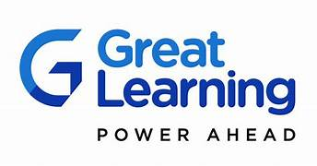

**SOFTWARE REQUIREMENTS:**

**Programming Language:** JAVA(8.0

**Framework:** Spring boot,Node JS,React JS

**Database:** MYSQL(8.0)

**Frontend:** HTML,CSS,JAVASCRIPT

**Additional Libraries:** NumPy, Pandas

**FLOW CHART:**

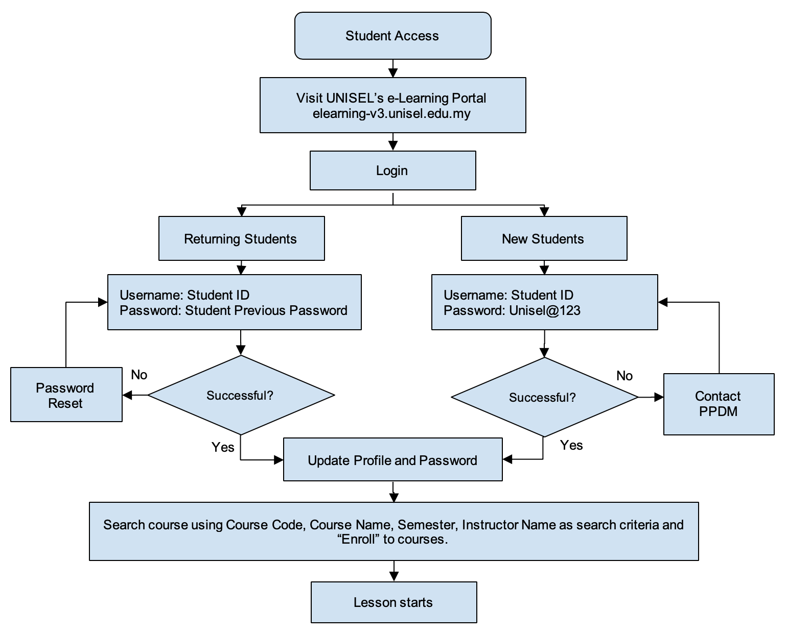

Login_username

Login_id

User password

User_id

Per_id

User_name

Login

Cor_desc

Cor_type

Cor_name

Cor_id

Cor_stu_id

course

Admin_id

Admin_email

Admin_pass

admin

Stu_id

Stu_pass

Stu_addr

Stu_email

Stu_name

Student

Manage

Per_module

Per_name

Permission

HAS

User

User_address

User_email

User_phno

**CODE:**

**<!DOCTYPE html>**

**<html lang="en">**

**<head>**

**<meta charset="UTF-8">**

**<meta name="viewport" content="width=device-width, initial-scale=1.0">**

**<title>E-Learning Platform</title>**

**<style>**

**body {**

**font-family: 'Arial', sans-serif;**

**margin: 0;**

**padding: 0;**

**background-color: #f4f4f4;**

**}**

**header {**

**background-color: #333;**

**color: white;**

**padding: 10px;**

**text-align: center;**

**}**

**nav {**

**display: flex;**

**justify-content: space-around;**

**background-color: #555;**

**padding: 10px;**

**}**

**nav a {**

**color: white;**

**text-decoration: none;**

**padding: 10px;**

**border-radius: 5px;**

**}**

**nav a:hover {**

**background-color: #777;**

**}**

**.course-container {**

**display: flex;**

**flex-wrap: wrap;**

**justify-content: space-around;**

**margin: 20px;**

**}**

**.course-card {**

**background-color: white;**

**border: 1px solid #ddd;**

**border-radius: 5px;**

**padding: 15px;**

**margin: 10px;**

**width: 300px;**

**box-shadow: 0 4px 8px rgba(0, 0, 0, 0.1);**

**}**

**.compiler-container {**

**max-width: 800px;**

**margin: 20px auto;**

**background-color: white;**

**padding: 20px;**

**border-radius: 5px;**

**box-shadow: 0 4px 8px rgba(0, 0, 0, 0.1);**

**}**

**.compiler-iframe {**

**width: 100%;**

**height: 400px;**

**border: none;**

**}**

**</style>**

**</head>**

**<body>**

**<header>**

**<h1>E-Learning Platform</h1>**

**</header>**

**<nav>**

**<a href="#">Home</a>**

**<a href="#">Courses</a>**

**<a href="#">About</a>**

**<a href="#">Contact</a>**

**</nav>**

**<div class="course-container">**

**<div class="course-card" onclick="showCourse('HTML')">**

**<h3>HTML Basics</h3>**

**<p>Instructor: John Doe</p>**

**</div>**

**<div class="course-card" onclick="showCourse('CSS')">**

**<h3>CSS Fundamentals</h3>**

**<p>Instructor: Jane Smith</p>**

**</div>**

**<div class="course-card" onclick="showCourse('JavaScript')">**

**<h3>JavaScript Essentials</h3>**

**<p>Instructor: Bob Johnson</p>**

**</div>**

**<div class="course-card" onclick="showCourse('Java')">**

**<h3>Java Programming</h3>**

**<p>Instructor: Alice Jones</p>**

**</div>**

**</div>**

**<div class="compiler-container" id="compilerContainer">**

**<!-- Compiler iframe will be dynamically loaded here -->**

**</div>**

**<script>**

**function showCourse(courseId) {**

**const compilerContainer = document.getElementById('compilerContainer');**

**compilerContainer.innerHTML = '';**

**if (courseId === 'HTML') {**

**compilerContainer.innerHTML = `**

**<h2>HTML Basics</h2>**

**<iframe class="compiler-iframe" src="https://www.w3schools.com/html/tryit.asp?filename=tryhtml_default" frameborder="0"></iframe>**

**`;**

**} else if (courseId === 'CSS') {**

**compilerContainer.innerHTML = `**

**<h2>CSS Fundamentals</h2>**

**<iframe class="compiler-iframe" src="https://www.w3schools.com/css/tryit.asp?filename=trycss_default" frameborder="0"></iframe>**

**`;**

**} else if (courseId === 'JavaScript') {**

**compilerContainer.innerHTML = `**

**<h2>JavaScript Essentials</h2>**

**<iframe class="compiler-iframe" src="https://www.w3schools.com/js/tryit.asp?filename=tryjs_default" frameborder="0"></iframe>**

**`;**

**} else if (courseId === 'Java') {**

**// Add Java compiler URL here**

**compilerContainer.innerHTML = `**

**<h2>Java Programming</h2>**

**<p>Java compiler iframe goes here</p>**

**`;**

**}**

**}**

**</script>**

**</body>**

**</html>**

**OUTPUT:**

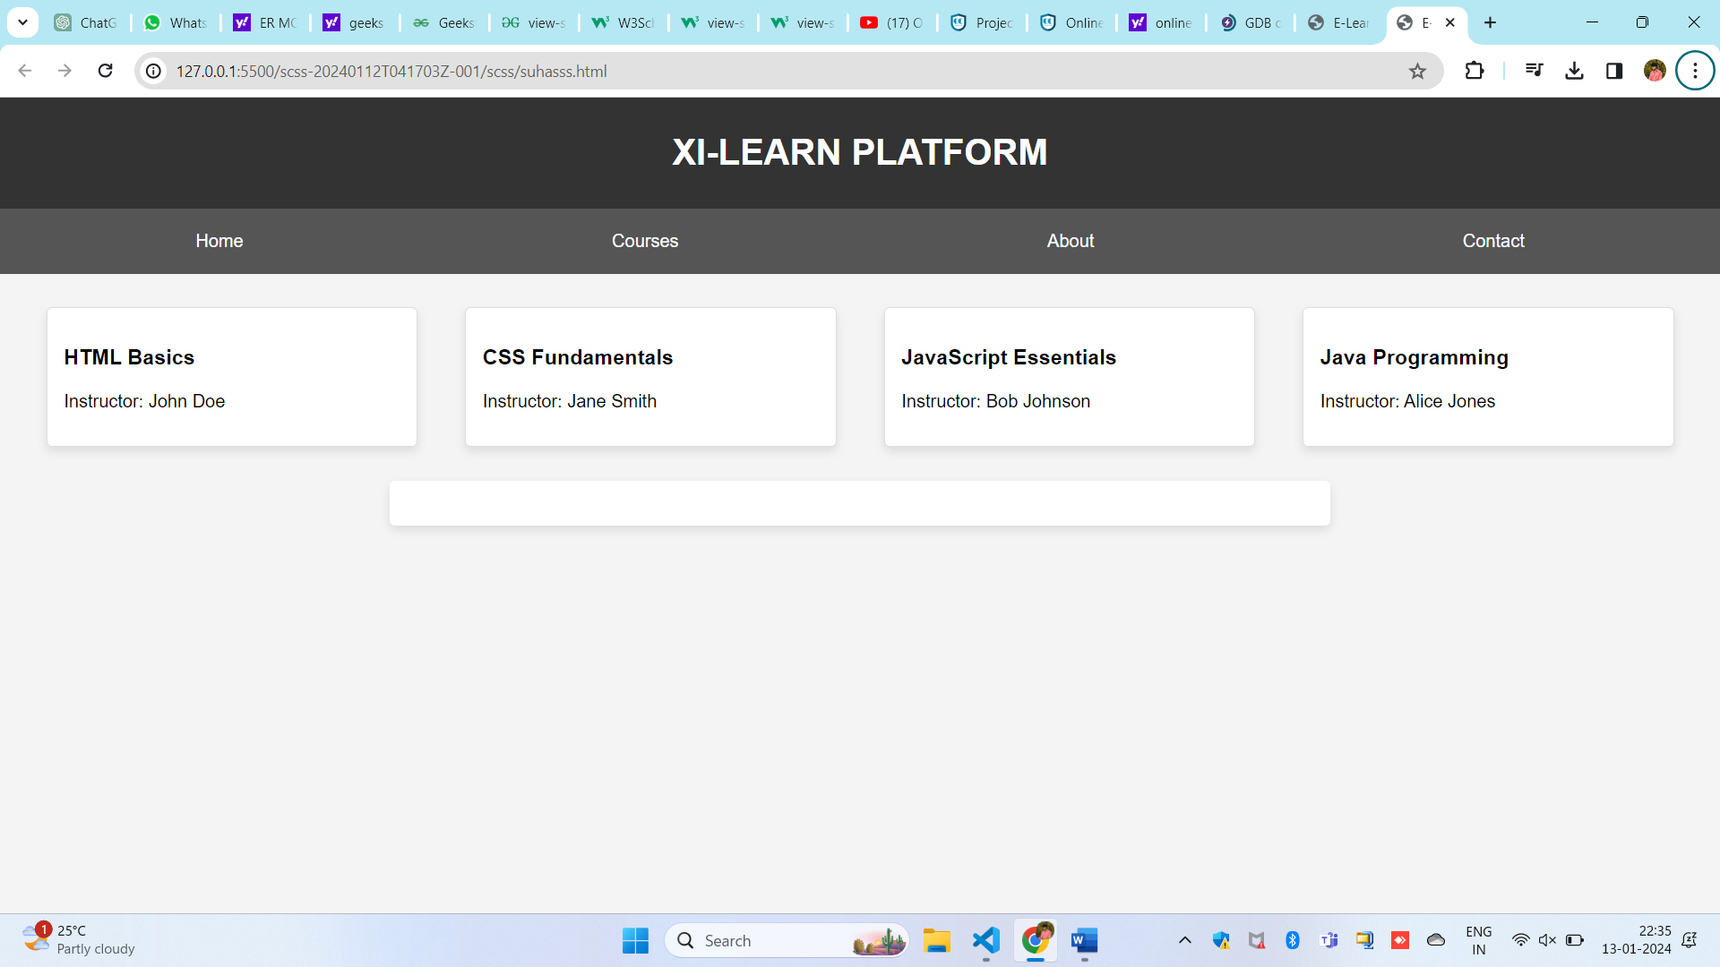

**CONCLUSION:**

In conclusion, our e-learning platform stands as a beacon of knowledge, fostering a dynamic and accessible learning environment. Through a thoughtful blend of diverse courses and interactive tools, we empower learners to explore the realms of HTML, CSS, JavaScript, Java, and beyond. As we bridge the gap between education and technology, our commitment to user-centric design ensures an enriching experience for all. With a focus on innovation, adaptability, and continuous improvement, we aspire to be a catalyst for lifelong learning. Together, we embark on a journey where education knows no boundaries, and the pursuit of knowledge becomes an immersive and fulfilling adventure. Thank you for being a part of our educational community, where the possibilities for learning are limitless.

**REFERENCES:**

1. Siemens, G. (2005). Connectivism: A Learning Theory for the Digital Age. International Journal of Instructional Technology and Distance Learning, 2(1), 3-10.
2. Johnson, L., Adams Becker, S., Estrada, V., and Freeman, A. (2014). NMC/CoSN Horizon Report: 2014 K-12 Edition. The New Media Consortium.
3. Anderson, T., & Dron, J. (2011). Three Generations of Distance Education Pedagogy. The International Review of Research in Open and Distributed Learning, 12(3), 80-97.
4. Iiyoshi, T., & Kumar, M. S. V. (2008). Opening Up Education: The Collective Advancement of Education through Open Technology, Open Content, and Open Knowledge. MIT Press.
5. Bates, A. W., & Sangrà, A. (2011). Managing Technology in Higher Education: Strategies for Transforming Teaching and Learning. John Wiley & Sons.
6. Allen, I. E., & Seaman, J. (2013). Changing Course: Ten Years of Tracking Online Education in the United States. Babson Survey Research Group and Quahog Research Group.
7. Khan Academy. (<https://www.khanacademy.org/>): A leading online learning platform offering a wide range of free courses.
8. Coursera. (<https://www.coursera.org/>): A massive open online course (MOOC) platform partnering with universities and organizations worldwide.
9. edX. (<https://www.edx.org/>): Another prominent MOOC platform founded by MIT and Harvard University.
10. Quality Matters. (<https://www.qualitymatters.org/>): A non-profit organization promoting quality assurance in online education.